AQUA-AUTOMATIC-FEEDING-SYSTEM

**Abstract:**

India is the world’s third largest aqua producing country. In India’s GDP Fish production contributes around 1% and in agricultural sector over 5%. Pet ownership in India has increased by 14% over the past 29 years. It is not feasible for fish owners to leave extra food in their fish"s tank before leaving for an extended period. And overfeeding fish is one of the leading causes of fish fatality. When the food begins to break down in the tank, the proteins release ammonia, nitrites, and reduce the amount of oxygen in the water, which are harmful for the fish as it leads to its death after few days. There are many options available for feeding cats and dogs, but there are not as many choices for fish owners. Natural food is already available in the pond. It may include detritus, bacteria, plankton. Supplementary feeds are regularly distributed to the fish in the pond. It is very difficult to determine how much artificial food should be distributed regularly to each pond. The quality of water in that pond is also another factor to be considered to obtain the best results. It is also not feasible for fish owners to feed them in a proper cycle especially during their in-availability. The flow of water fish ponds discusses on how every day should be monitored. This project ensures quality by handling the PH and temperature. This system is designed to monitor the water temperature, quality and automatic feeding of an aquaculture environment

Requirements:

* Nitrate levels should be from 0-40ppm
* PH values should be 6.5-9.0
* Temperature for fish to do well are from 75-80 degree Fahrenheit(23-27 degree Celsius)
* The favourable dissolved oxygen level is between 5-20ppm
* Ammonia =0ppm

Set-UP:

* In this we are using a Arduino mega to which 12v dc voltage is supplied
* Arduino is connected with nitrate sensor, PH-sensor ,water level sensor, temperature sensor, and a servo mot0r
* a heater or light to maintain the required temperature range and water in/out pumps are connected to Arduino through relay to on and off the pumps
* And all these sensors , heater are connected from aquarium to arduino
* And the water pumps are connected from Arduino to aquarium
* 230v dc, 12v dc ,12v dc are supplied to the heater, water in/out pumps respectively
* And an external pump with 230v ac is connecter to aquarium

BLOCK DIAGRAM:

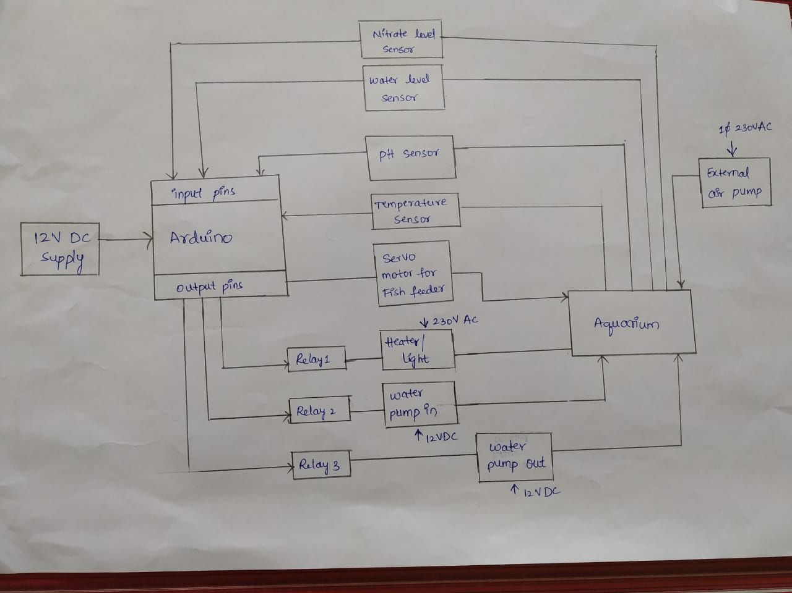

Water level checker:

The operation of circuit start with water level sensor, arduino checks the water level if it is not upto the level then it will sends high signal to the relay to input water pump to fill the water then after reaching required level it sends low signal to the off the switch

PH sensor:

PH sensor will check the ph level if it is upto required level then Arduino continue its process else it will sends high signal to the relay to output pump to remove the water from the tank after that Arduino sends high signal to the relay to input water pimp to fill the tank.

Temperature sensor:

It checks the temperature of the water if it is in required range then The

Arduino will switch over to the fish feeder to activate it .otherwise it will sends

High signal to the relay to activate heater then Arduino will check for the

required range of temperature then it will sends low signal to relay to

switch off the heater

Air pump:

Air pumps are connected independently to the aqua tank without any control of Arduino. Air pump is to be operated 24 hrs since the oxygen is the main source of living for aqua species